Experiment – 4
JQuery

What is jQuery?
jQuery is an efficient & fast JavaScript Library created by John Resig in 2006. The motto of jQuery is write less, do more, because it’s functionality revolves around simplifying each and every line of code.

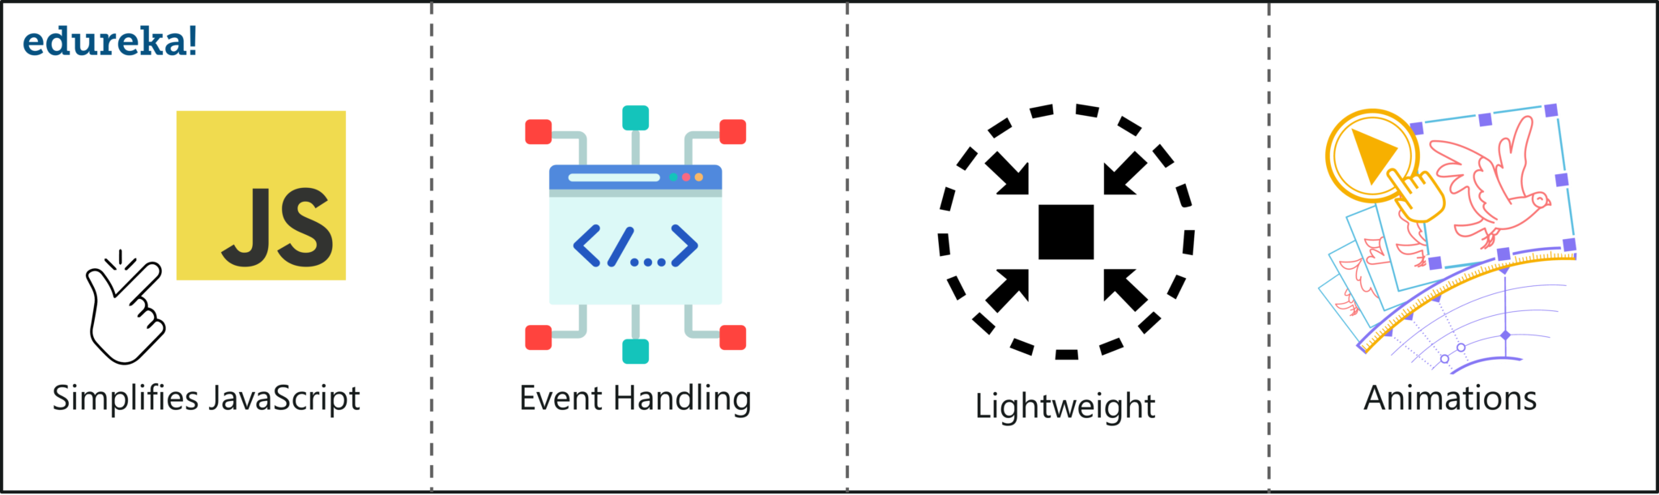

Why use jQuery?
We’re all aware that there are 100s of JavaScript frameworks and libraries out there, but why you should use jQuery?
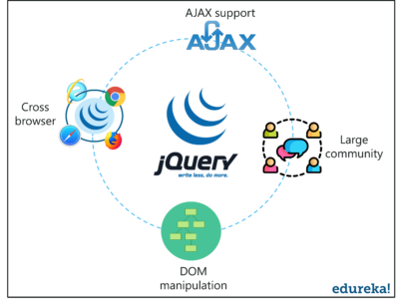

j
- JQuery makes it extremely easy to manipulate the DOM. In order to make a web app more interactive, web developers manipulate the DOM & jQuery makes it very easy to do that
- Community of its users is more diverse than any other JavaScript library. It provides detailed documentation which is all a developer needs
- jQuery has 1000s of plugins available for free, which improve the user experience. One such example is the AJAX (Asynchronous JavaScript And XML) which develops a responsive and feature rich site
- jQuery provides cross-browser support which lets you run your code on different browsers without worrying about dependency issues

Install jQuery
There’s no installation per se, it’s more like downloading jQuery. There are two ways to install jQuery:
- Local Installation:You can directly download jQuery library from their official website and include it in your HTML code
- Link to a CDN:You can add jQuery library in your HTML code from Content Delivery Network
<script type="text/javascript" src="https://code.jquery.com/jquery-3.3.1.min.js"></script>
Use https://jquery.com/download/ to download jQuery

The $() factory function
Every jQuery selector start with thiis sign $(). This sign is known as the factory function. It uses the three basic building blocks while selecting an element in a given document.

S.No. | Selector | Description
1) | Tag Name: | It represents a tag name available in the DOM.  For example: $('p') selects all paragraphs'p'in the document.
2) | Tag ID: | It represents a tag available with a specific ID in the DOM.  For example: $('#real-id') selects a specific element in the document that has an ID of real-id.
3) | Tag Class: | It represents a tag available with a specific class in the DOM.  For example: $('.real-class') selects all elements in the document that have a class of real-class.

#id | $("#firstname") | It will select the element with id="firstname"
.class | $(".primary") | It will select all elements with class="primary"
class,.class | $(".primary,.secondary") | It will select all elements with the class "primary" or "secondary"
element | $("p") | It will select all p elements.

jQuery Effects
jQuery enables us to add effects on a web page. jQuery effects can be categorized into fading, sliding, hiding/showing and animation effects.
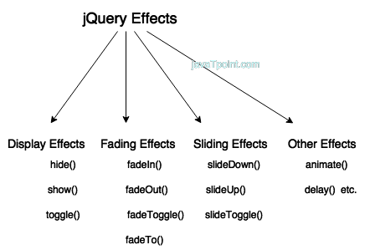

No. | Method | Description
1) | animate() | performs animation.
2 | clearQueue() | It is used to remove all remaining queued functions from the selected elements.
3) | delay() | sets delay execution for all the queued functions on the selected elements.
4 | dequeue() | It is used to remove the next function from the queue, and then execute the function.
5) | fadein() | shows the matched elements by fading it to opaque. In other words, it fades in the selected elements.
6) | fadeout() | shows the matched elements by fading it to transparent. In other words, it fades out the selected elements.
7) | fadeto() | adjusts opacity for the matched element. In other words, it fades in/out the selected elements.
8) | fadetoggle() | shows or hides the matched element. In other words, toggles between the fadeIn() and fadeOut() methods.
9) | finish() | It stops, removes and complete all queued animation for the selected elements.
10) | hide() | hides the matched or selected elements.
11) | queue() | shows or manipulates the queue of methods i.e. to be executed on the selected elements.
12) | show() | displays or shows the selected elements.
13) | slidedown() | shows the matched elements with slide.
14) | slidetoggle() | shows or hides the matched elements with slide. In other words, it is used to toggle between the slideUp() and slideDown() methods.
15) | slideup() | hides the matched elements with slide.
16) | stop() | stops the animation which is running on the matched elements.
17) | toggle() | shows or hides the matched elements. In other words, it toggles between the hide() and show() methods.

jQuery toggle()
The jQuery toggle() is a special type of method which is used to toggle between the hide() and show() method. It shows the hidden elements and hides the shown element.

<!DOCTYPE html>
- <html>
- <head>
- <script src="http://ajax.googleapis.com/ajax/libs/jquery/1.11.2/jquery.min.js"></script>
- <script>
- $(document).ready(function(){
- $("button").click(function(){
- $("div.d1").toggle();
- });
- });
- </script>
- </head>
- <body>
- <button>Toggle</button>
- <div class="d1" style="border:1px solid black;padding:10px;width:250px">
- <p><b>This is a little poem: </b><br/>
- Twinkle, twinkle, little star<br/>
- How I wonder what you are<br/>
- Up above the world so high<br/>
- Like a diamond in the sky<br/>
- Twinkle, twinkle little star<br/>
- How I wonder what you are</p>
- </div>
- </body>
- </html>

jQuery fadeIn()
Is used to fade in the element.

jQuery fadeOut()
Is used to fade out the element.

jQuery text()
Return the text content of the selected elements.

jQuery Callback Functions
JavaScript statements are executed line by line. However, with effects, the next line of code can be run even though the effect is not finished. This can create errors.
To prevent this, you can create a callback function.
A callback function is executed after the current effect is finished.
Typical syntax:$(selector).hide(speed,callback);
Examples
The example below has a callback parameter that is a function that will be executed after the hide effect is completed:

Example with Callback

$("button").click(function(){
$("p").hide("slow", function(){
alert("The paragraph is now hidden");
});
});

Example without Callback
$("button").click(function(){
$("p").hide(1000);
alert("The paragraph is now hidden");
});

Assignment 1
- 1)Set the focus to the first input box.
- Set background color of an element when the element (or any elements inside it) gets focus or loses focus
- Display the keyboard key which was pressed in a textbox? All keys corresponding to a string
- Run an animation to show/hide a product explanation div
- Finds all elements that are checked or selected
- Change the color of a paragraph to red on mouseover event
- Click a word in the paragraph and highlight it
- Create a form that has input fields but no labels. Display labels on focus.

